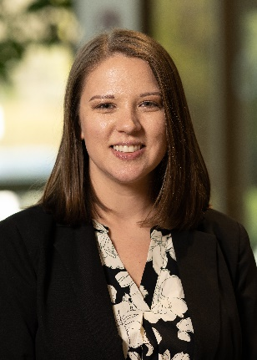
The Path Forward: Key Market Trends &
Insights for 2025

Moderator
Kelly Hansen
Operations Manager
Legacy Advisors, LLC

Kelly is an Operations Manager with Legacy Advisors, LLC, and joined the firm in 2022. In her current role, she is responsible for overseeing the day-to-day operational activities of the firm, ensuring efficiency in processes and supporting the delivery of exceptional client service. She plays a key role in maintaining seamless internal workflows and contributes to the strategic planning and execution of initiatives that enhance the client experience. Kelly’s commitment to operational excellence ensures that Legacy Advisors continues to deliver superior value to its clients.

Prior to her current role, Kelly served as a Client Coordinator and was instrumental in managing client interactions, coordinating schedules and facilitating communication between clients and advisors. Her dedication to building strong client relationships and providing outstanding service laid the foundation for her transition into leadership within the firm. Before joining Legacy Advisors, Kelly was the Operations Director for a Philadelphia-based upscale dining restaurant group, where she was responsible for overseeing multiple restaurant locations, managing large teams and ensuring operational excellence in a fast-paced environment.

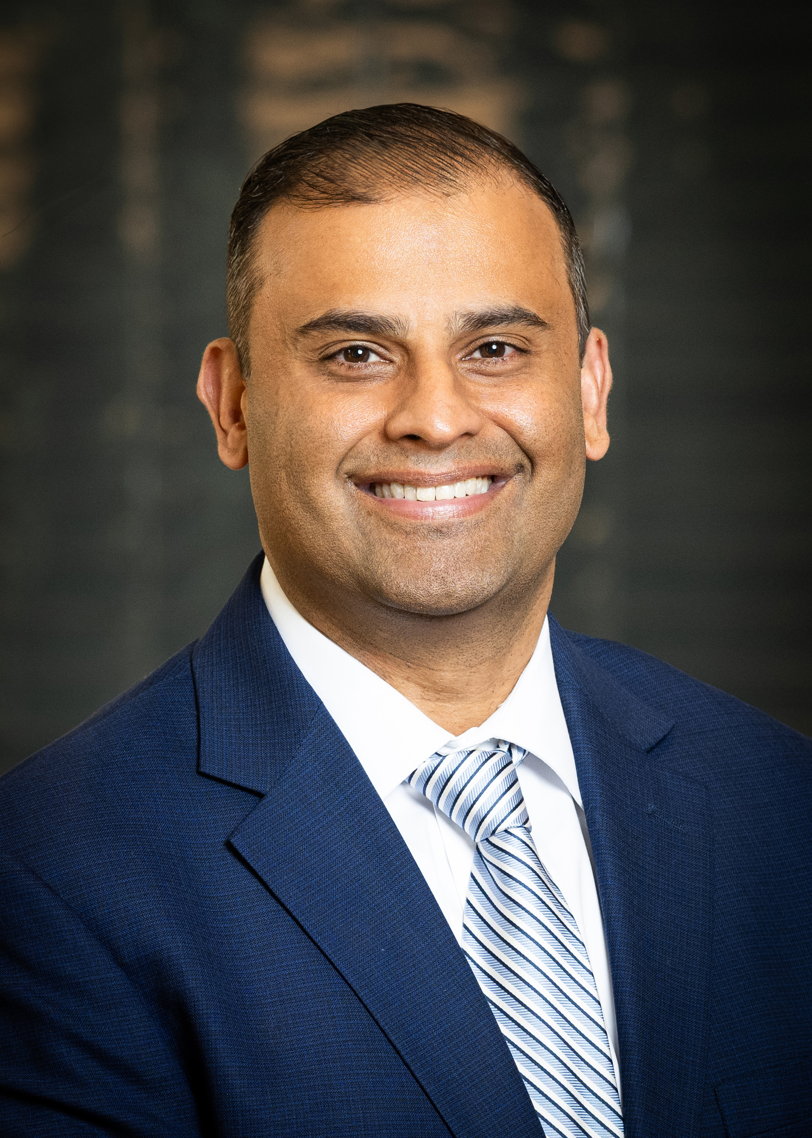

Ron Ahluwalia, CFA, CAIA, FRM
Investment Strategist/Portfolio Manager,
Legacy Advisors, LLC

Ron is an Investment Strategist/Portfolio Manager with Legacy Advisors, LLC, joining the firm in April 2024. He is responsible for investment manager due diligence across asset classes and assisting with portfolio construction and strategy. He also assists in the daily oversight of client portfolios, including implementation, rebalancing and investment weighting. He currently
serves on the company’s Investment Policy Committee. Ron has over 20 years of industry experience. Prior to his current role, he was Director–Due Diligence at Orion, where he provided oversight of the available universe of third-party investment strategies across the firm’s open architecture platform.

Prior to Orion’s acquisition of Brinker Capital, he was Vice President and Senior Portfolio Manager within the firm’s Wealth Advisory team responsible for the portfolio management, investment planning and communication of multiasset portfolios for high-net-worth clients and institutions. He also has held roles at SEI Investments, Russell Investments and Lincoln Financial Group, where he served institutional and individual investors in constructing asset allocation policies, portfolio management and investment manager due diligence. He received his Bachelor of Business Administration in risk management and actuarial science from Temple University. He is a CFA®, CAIA®, and FRM charterholder and a member of the CFA® Society of Philadelphia and the CFA Institute.

Dianne Pagano Manges, CFA
Director, Senior OCIO Investment Advisor
Truist Foundations & Endowments Specialty

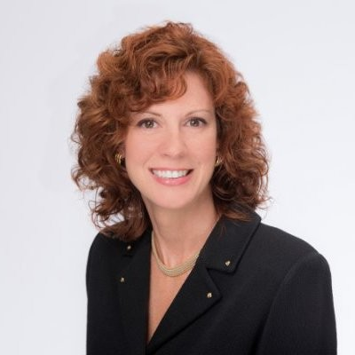

Dianne is a Senior OCIO Investment Advisor with the Truist Foundations & Endowments Specialty Practice. She advises on the development and implementation of investment solutions to help nonprofit clients meet their short- and long-term goals to maximize their impact.

In her 30-plus-year career, Dianne has held senior investment management and investment committee roles and has authored regular economic and market commentaries. She earned a bachelor’s degree in economics from Immaculata University, where she graduated summa cum laude, and was awarded the top medal in the Economics program. She is also a Chartered Financial Analyst, CFA®.

Dianne is a member of the Board of Trustees for Immaculata University. She serves as Vice-Chair of the Board of Gemma Services Foundation and as a mentor with “Inve$t in Her Future.” She is an active member and past Board of Governor of the CFA Society of Philadelphia, where she serves on the planning committee for the Annual Endowments & Foundations Conference. Dianne is past president and member of The Bond Club of Philadelphia and a member of the
Philadelphia Council for Business Economics, Women in Investing Network, Global Interdependence Center, Women United of United Way Greater Lehigh Valley, Society of Professional Women of the Main Line Chamber and Women Influencing Business Council of the Chester County Chamber. She serves on the Planning Committees for the One Step Forward Gala for The Arc of Lehigh County, the Lehigh Valley Philanthropy Institute, and the Women’s Business Council of the Lehigh Valley Chamber.

